SET-14

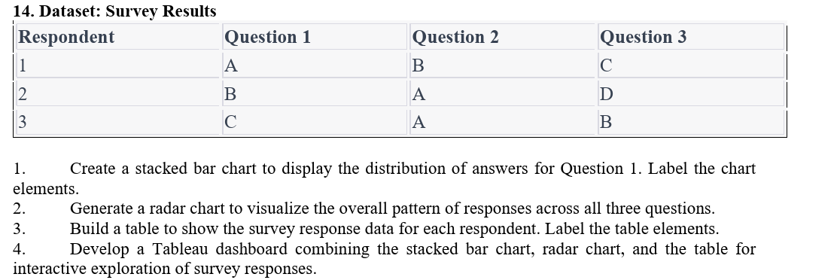

1. Create a stacked bar chart for Question 1

Aim:
To create a stacked bar chart showing the distribution of answers for Question 1.

Code:

library(ggplot2)

q1 <- as.data.frame(table(survey$Question1))

ggplot(q1, aes(x="", y=Freq, fill=Var1)) +

geom_bar(stat="identity") +

labs(title="Question 1 Responses",

x="Question 1", y="Count", fill="Answer")

Output:
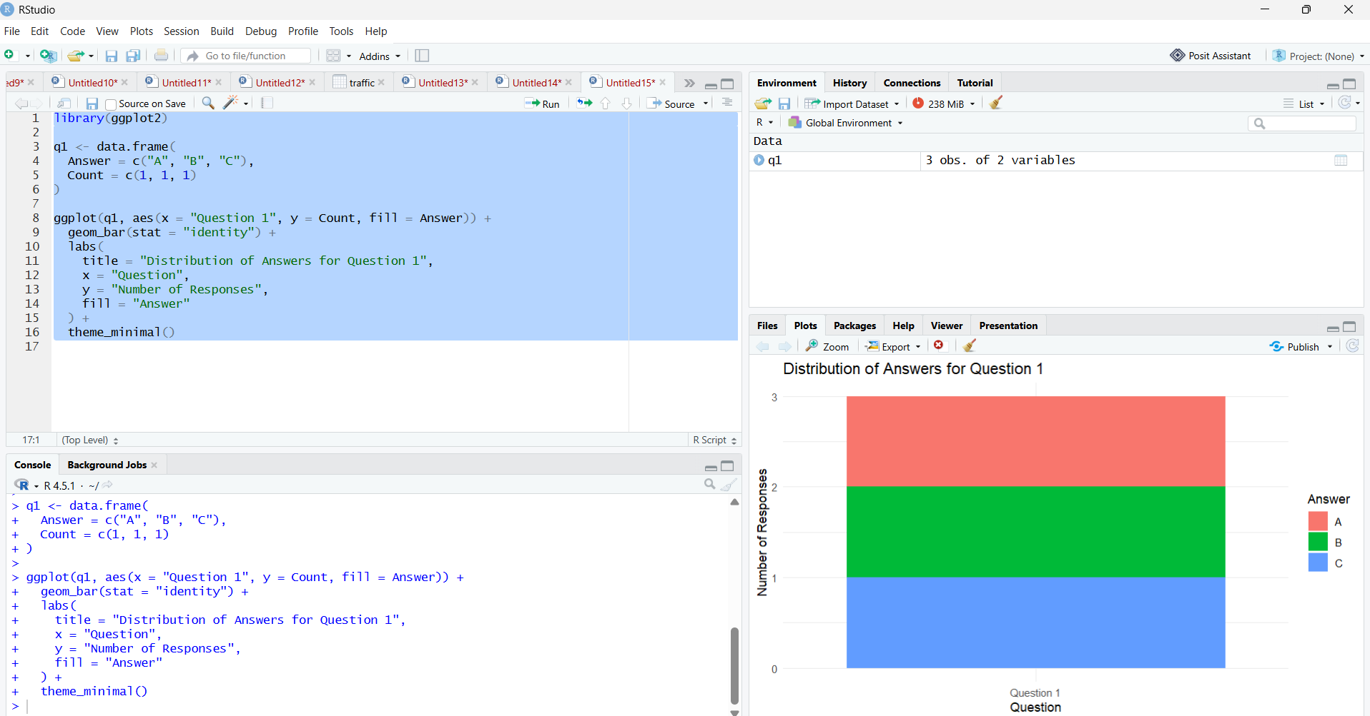
2. Generate a radar chart for all three questions
Aim:
To visualize the overall pattern of responses across all three questions using a radar chart.
Code:
library(fmsb)
data <- data.frame(
A=c(3,0,1,1),
B=c(3,0,1,1),
C=c(3,0,1,1),
D=c(3,0,0,1)
)
rownames(data) <- c("Max","Min","Q1","Q2")
radarchart(data,
title="Survey Response Pattern")

Output:

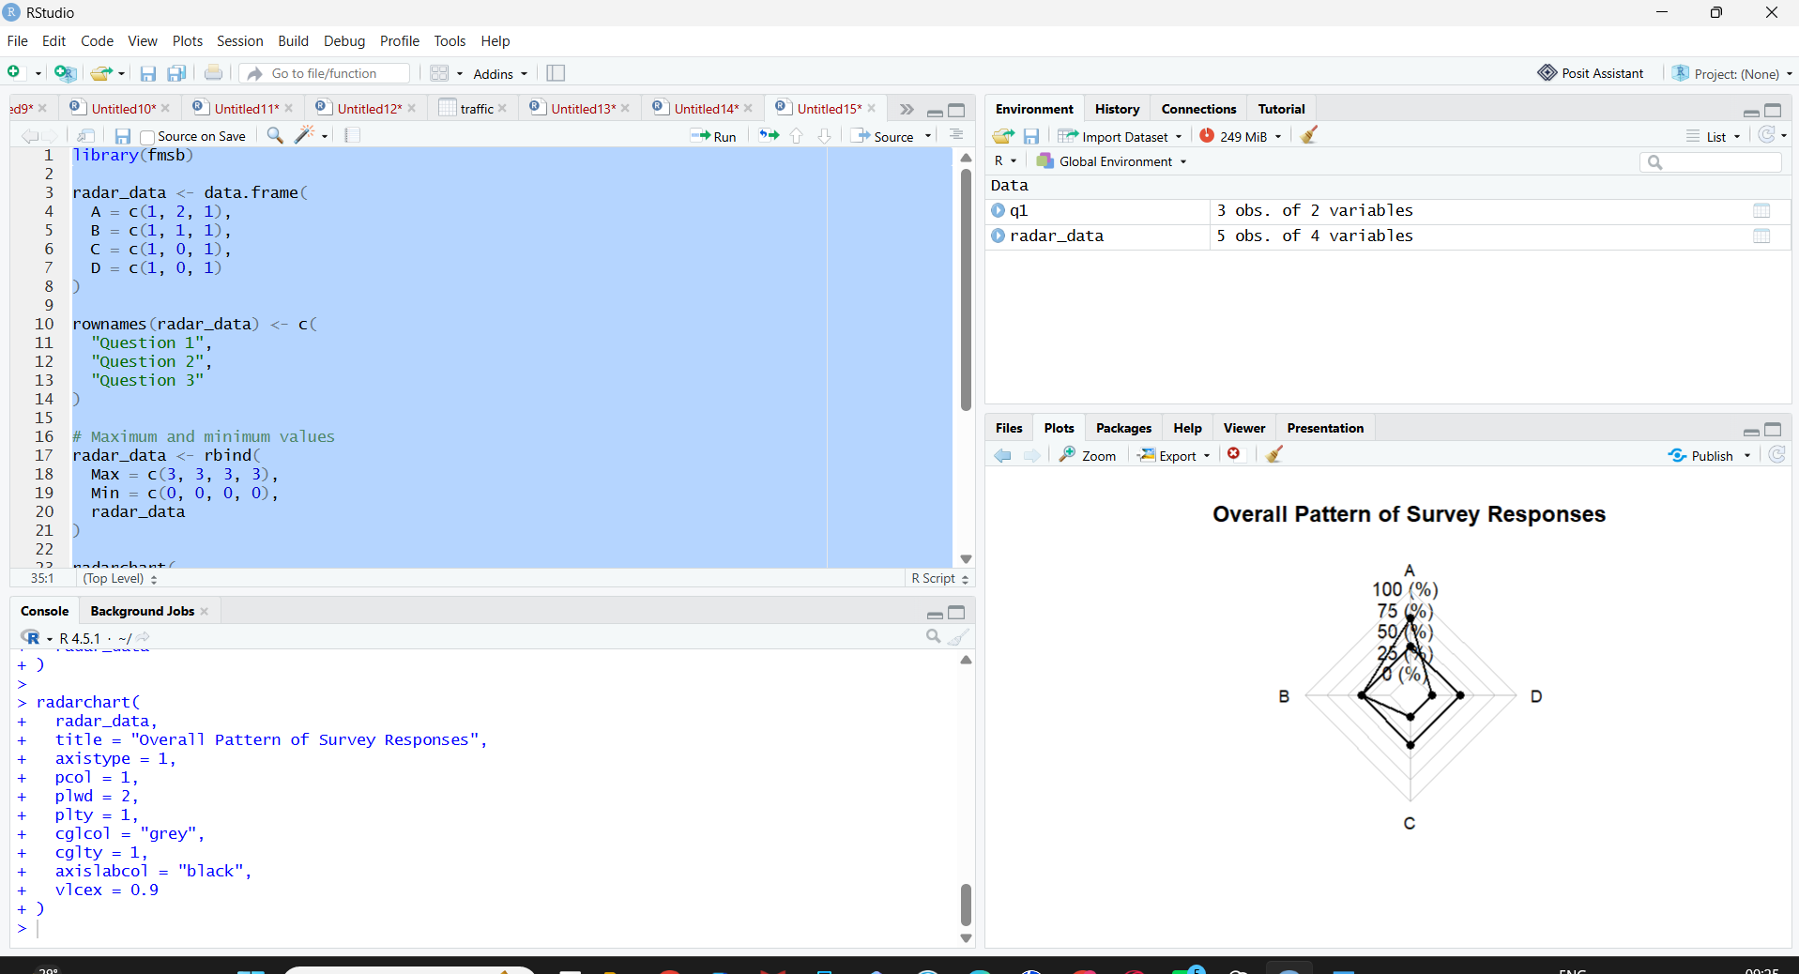
3. Build a table showing survey responses
Aim:
To display the survey response data for each respondent in tabular form.
Code:
survey <- data.frame(
Respondent = c(1,2,3),
Question1 = c("A","B","C"),
Question2 = c("B","A","A"),
Question3 = c("C","D","B")
)

View(survey)

Output:
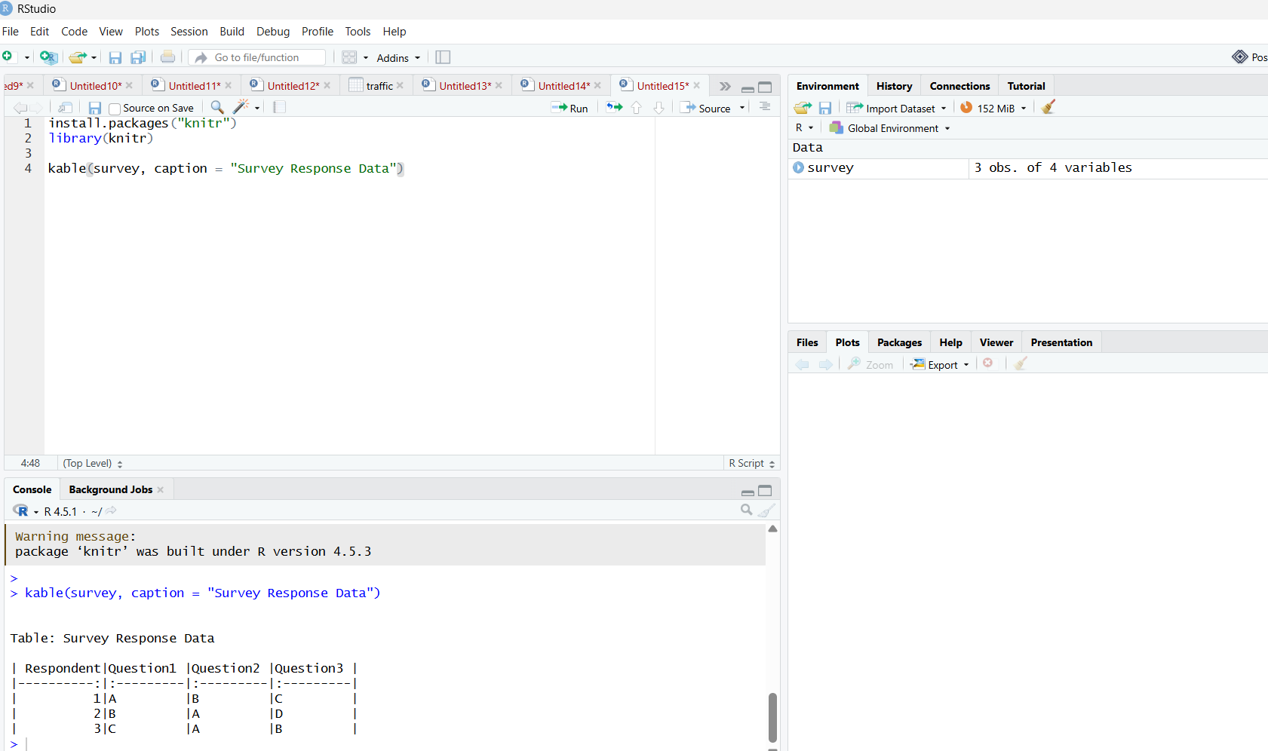

4. Tableau Dashboard Data
Aim:
To prepare survey data for creating an interactive Tableau dashboard.
Output:

